1. **Introduction**

The Project “Automatic Light System for Classroom” is a reliable circuit that automatic controls the class room lights. When somebody enters into the class room then PIR sensor detects it and the switches ON the classroom lights. When any one leaves the class room, it waits for some time and then if no one enters the classroom PIR sensor Switches OFF the classroom. Lots of people in this world are without electricity and modern lighting. This problem is more severe in rural areas or in cities. The rural electrification varies widely from country to country. Our country India frequently suffers from unreliable and intermittent electricity supply. In some places, people get electricity only few hours of the day only. Without adequate electricity, it becomes challenging for adult towards concentrating on their professional work or study. Rural communities of course needs a reliable and sustainable Solution for lighting towards providing a brighter future. The country has made significant progress towards the augmentation of its power infrastructure.

* 1. Problem Definition

“Automatic Light System for Classroom”.

* 1. Aims & objectives of project

To develop Automated Light System for Classroom using IOT has following objectives:

1. Energy Consumption.

2. Human Detection.

* 1. Scope & limitation of project

Scope:

* We can use this system in home, college, offices etc.
* We can use this system for automation purpose in IOT.

Limitations:

* Multiple persons entering room cannot be detected.
  1. Timeline for project

According to our plan, this project will be completed till April 2019.

* 1. Timeline for project

According to our plans, this project will be completed till April 2019.

|  |  |  |
| --- | --- | --- |
| **Sr. No.** | **Description** | **Dates** |
| 1 | Domain/Problem statement Identification | 13/07/2018 to 20/07/2018 |
| 2 | Requirement Analysis | 20/07/2018 to 03/08/2018 |
| 3 | Designing | 03/08/2018 to 24/08/2018 |
| 4 | Coding | 24/08/2018 to 13/02/2019 |
| 5 | Testing | 13/02/2019 to 28/02/2019 |
| 6 | Analysis | 28/02/2019 to 12/03/2019 |
| 7 | Report Writing | 12/03/2019 to 5/04/2019 |

* 1. Cost of Project
     1. Raspberry Pi Board:-Rs. 2750.
     2. PIR sensor (2):- 140*2= Rs. 280.
     3. LCD Display:-Rs. 120.
     4. Memory Card:-Rs. 300.
     5. Relay:-Rs. 300.
     6. Wires:-Rs. 150.
     7. LCD connection:-Rs. 10.
     8. 12V Adaptor:-Rs.140.
     9. Bulb:-Rs. 50.

**Total**:-Rs. 4000.

1. **Background Study and Literature Review**
   1. Literature overview

* H. N. S. Anushaet. al. [1] has developed Automatic Lighting and Control System for Classroom. Class room divided into grids and PIR sensor placed towards capturing the entrance of human inside it and also presence of human in the appropriate Grid for switching appliances on or off by sending signal to relay. Energy consumption is reduced to 36%.
* Himanshu Singh et.al.[2] has developed IoT based Smart Home Automation System using Sensor Node. They had developed home automation which controls some home appliances like Light and Fan using sensors like PIR sensor, Arduino. The proposed solution uses the sensor and detects the presence or absence of a human object in the housework accordingly. This solution also provides information about energy consumed. We achieved the development of Smart Home by using the Internet of Things technologies.

1. **Requirement Analysis**
   1. **Functional Requirements**

1) External interface Requirements

* 1. PIR Sensor:
* Input : Human Detection.
* Output : If person enter in classroom light is ON

Otherwise OFF

* 1. Raspberry-pi
* Input : Get signal (data) from PIR sensors.
* Output: Raspberry-pi send signals to LCD display and relay.
  1. Relay and LCD display:
* Input : Get signals from Raspberry-pi
* Output: Relay –Light ON/OFF, LCD display-display count.
  1. **System Requirements**

1. Hardware Requirements

* CPU: 1 GHz processor
* RAM: 4 GB
* HARD DISK: 500GB
* DEVICES:2 PIR Sensor, Raspberry Pi3, Relay, LCD display.

1. Operating System Requirements

* Raspbian OS.
* Windows OS.

1. Tools and Technologies Requirements

* Language : Python

1. **System Design**
   1. Architectural Design

Figure 4.1 shows the architectural design of project. The architectural design shows the main model of the project.

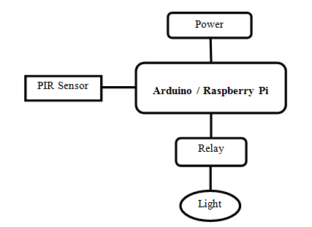

Fig. 4.1 System Architecture

* **PIR sensor**:PIR sensors allow you to sense motion, almost always used to detect whether a human has moved in or out of the sensors range. They are small, inexpensive, low-power, easy to use and don't wear out. For that reason they are commonly found in appliances and gadgets used in homes or businesses. They are often referred to as PIR, "Passive Infrared", "Pyroelectric", or "IR motion" sensors.

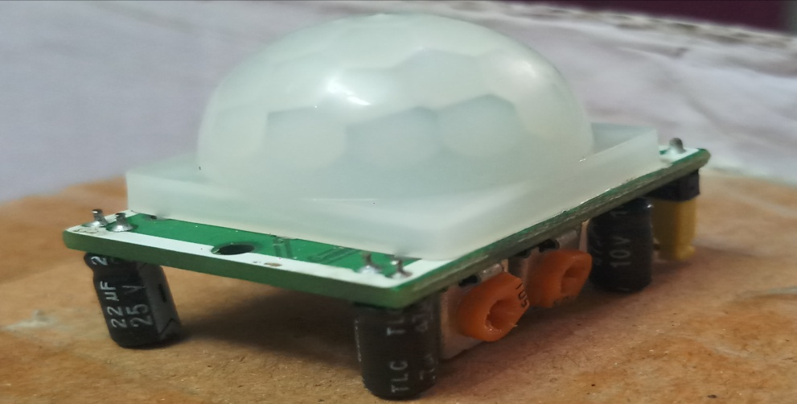

Fig. 4.2 PIR Sensor

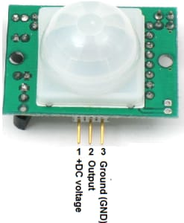

Fig. 4.3 PIR sensor pin diagram

* **Raspberry Pi**:It is a mini computer with Raspbian OS.It can run multiple programs at a time.It is difficult to power using a battery pack.It requires complex tasks like installing libraries and software for interfacing sensors and other components.Raspberry Pi can be easily connected to the internet using Ethernet port and USB Wi-Fi dongles.Raspberry Pi did not have storage on board. It provides an SD card port.Raspberry Pi has 4 USB ports to connect different devices.The processor used is from ARM family.This should be properly shutdown otherwise there is a risk of files corruption and software problems.The Recommended programming language is python but C, C++, Python, ruby are pre-installed.

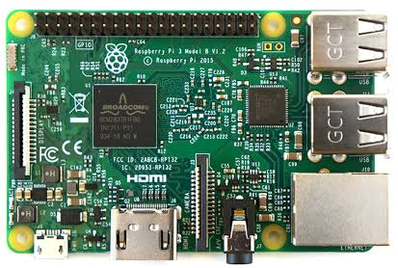

Fig. 4.4 Raspberry Pi

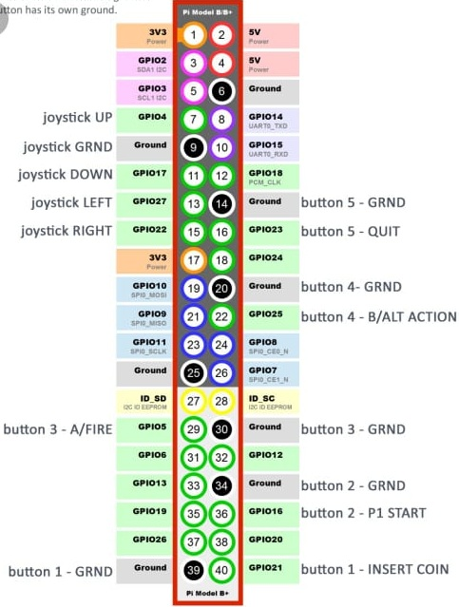

Fig. 4.5 Raspberry Pi pin configuration

* **Arduino**:Adriano is an open-source electronics platform based on easy-to-use hardware and software. [Arduino boards](https://www.arduino.cc/en/Main/Products) are able to read inputs - light on a sensor, a finger on a button, or a Twitter message - and turn it into an output - activating a motor, turning on an LED, publishing something online. You can tell your board what to do by sending a set of instructions to the microcontroller on the board. To do so you use the [Arduino programming language](https://www.arduino.cc/en/Reference/HomePage) (based on [Wiring](http://wiring.org.co/)), and [the Arduino Software (IDE)](https://www.arduino.cc/en/Main/Software), based on [Processing](https://processing.org/).
* **Relay**: A relay is an electromagnetic switch that is used to turn on and turn off a circuit by a low power signal, or where several circuits must be controlled.

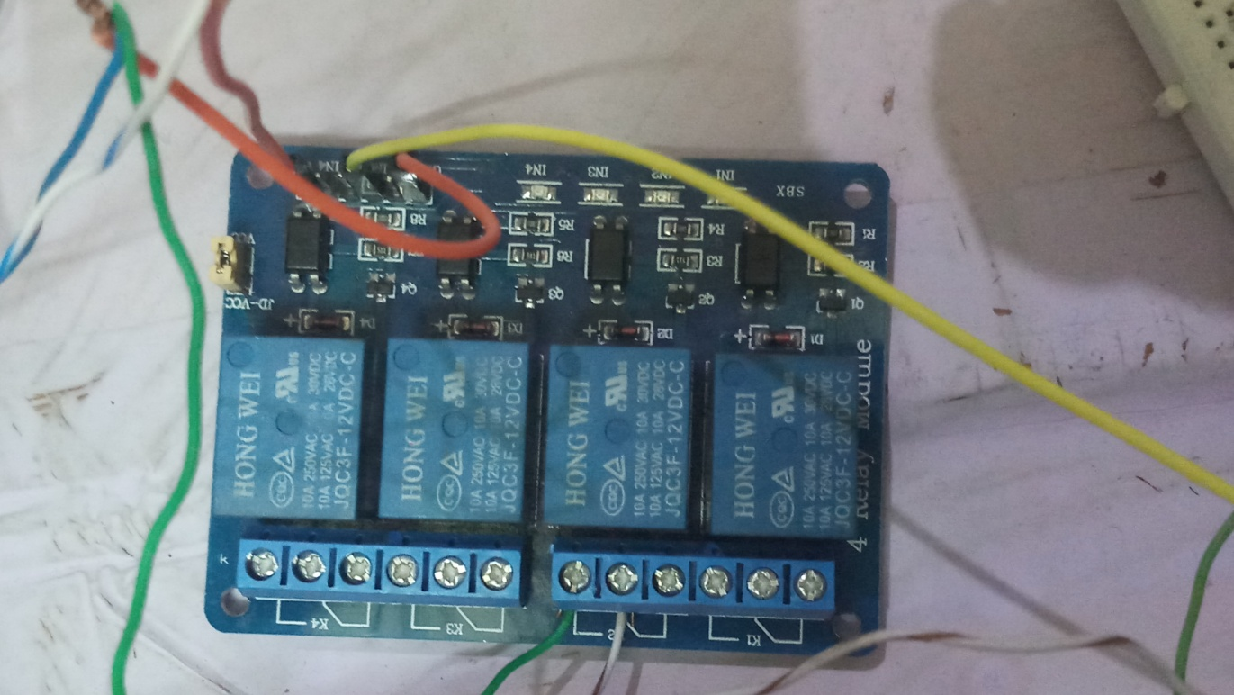

Fig. 4.6 Relay

* **Power Supply**: A power supply is an electrical device that supplies electric power to an electrical load. The primary function of a power supply is to convert electric current from a source to the correct voltage, current, and frequency to power the load.

b) Algorithmic description of each modules

Step1: Start

Step2: PIR sensor detects person

Step3: Declare GPIO PIN 11 as IN

GPIO PIN 35 as IN

GPIO PIN 3 as OUT

Step4: Take output of first PIR sensor via GPIO.input(11) which is input and store in

variable i. Take output of second PIR sensor via GPIO.input(35) which is input

and store in variable j.

Step5: If person enters in room then count is incremented by 1 and this count will be

displayed on LCD display and send signal to relay via GPIO.output(3) and then

light (bulb) will be ON.

Step6: If person leaves room then count is decremented by 1 and this count will be

displayed on LCD display. If count=0 then send signal to relay via

GPIO.output(3) and then light (bulb) will be OFF

Step7: End.

c) System Modeling

1) Dataflow Diagram

DFD level-0:

This Data flow Diagram level-0 shows the main system input and output of the Project.

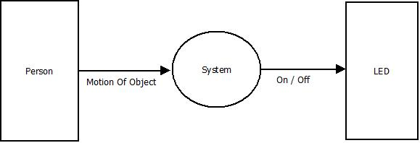

Figure 4.7: DFD level-0

DFD level-1:

This Data flow Diagram level-1 shows the internal models of our project and also their input and output.

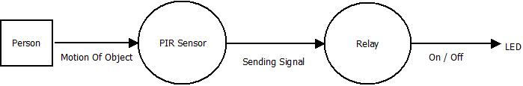

Figure 4.8: DFD level-1

2) Activity Diagram

Figure 4.9 shows the Activity diagram of the project. The Activity diagram shows the main Activity of the project. The Activity diagram shows the representations of workflows of stepwise activities and actions with support for choice, iteration and concurrency.

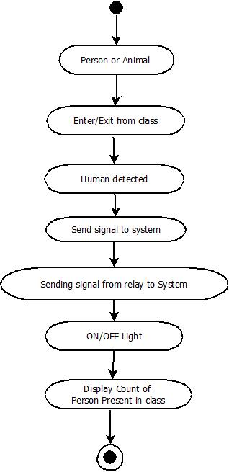

Figure 4.9: Activity Diagram

3) Collaboration Diagram

Figure 4.10 shows Collaboration diagram. A collaboration diagram, also called a communication diagram or interaction diagram, is an illustration of the relationships and interactions among software objects in the Unified Modeling Language (UML).A collaboration diagram shows the objects and relationships involved in an interaction, and the sequence of messages exchanged among the objects during the interaction.

Figure 4.10: Collaboration Diagram

1. Sequence Diagram

Figure 4.11 shows Sequence Diagram. The Sequence Diagram shows the Object Interaction arranged in time sequence. There are five modules present like PIR sensors, Raspberry-pi, Relay, Bulb, LCD Display. The Solid Bars shows the Active Time of the module. The Dotted Line shows the inactive time of model. In Sequence diagram, it shows the flow of project sequentially.

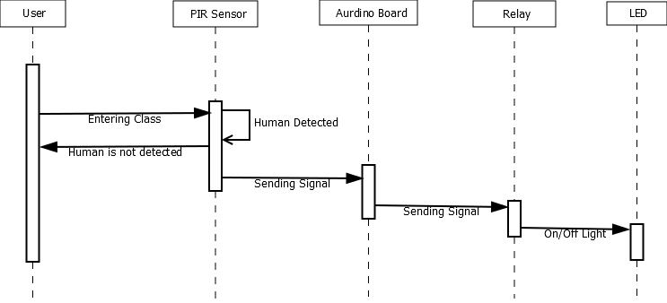

Figure 4.11: Sequence Diagram

1. Use case Diagram

Figure 4.12 shows the use case diagram of the project.The Use Case Diagram shows the main modules of the project.

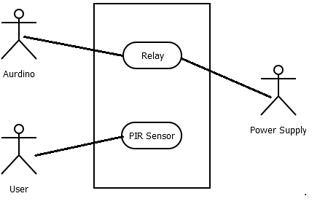Figure 4.12: Use Case Diagram

**5. Implementation**

a) Environmental settings for running the project

The following hardware as well as software settings is needed for execution of the project:

1. Install Raspbian operating system on raspberry pi.
2. Install libraries of LCD display.

b) Detailed description and methods

* Take components like PIR Sensor , Bread Board ,LCD display ,connection wires etc.
* PIR sensor has three pins Ground, VCC, Output pin and also two Potentiometers. one for adjusting the sensitivity of the sensor and the other for adjusting the time the output signal.

Table 5.1 PIR Sensor pin Description

|  |  |  |  |
| --- | --- | --- | --- |
| Sr. no. | Pin no. with discription  (PIR Sensor) | Pin no. with discription  (Raspberry Pi) | |
|  |  | First PIR sensor | Second PIR Sensor |
| 01 | Pin 1(VCC) | Pin 2 | Pin 4 |
| 02 | Pin 2(Output) | GPIO Pin 11 | GPIO Pin 35 |
| 03 | Pin 3(Ground) | Pin 6 | Pin 14 |

Table 5.2 LCD Display pin Description

|  |  |  |
| --- | --- | --- |
| Sr. no. | Pin no. with discription  (LCD Display) | Pin no. with discription  (Raspberry Pi) |
| 01 | Pin 1(Ground) | Pin 30 |
| 02 | Pin 2(Vcc) | Pin 2 |
| 03 | Pin 3(Ground) | Pin 34 |
| 04 | Pin 4(RS) | GPIO Pin 8 |
| 05 | Pin 5(R/W) | Ground Pin 9 |
| 06 | Pin 6(EN) | GPIO Pin 22 |
| 07 | Pin 11(DB4) | GPIO Pin 12 |
| 08 | Pin 12(DB5) | GPIO Pin 38 |
| 09 | Pin 13(DB6) | GPIO Pin 24 |
| 10 | Pin 14(DB7) | GPIO Pin 23 |
| 11 | Pin 15(Vcc) | Pin 4 |
| 12 | Pin 16(Ground) | Pin 20 |

* Do the connection as above pin description.

**6. Integration and testing**

a) Description of integration of modules and/or components with screenshots

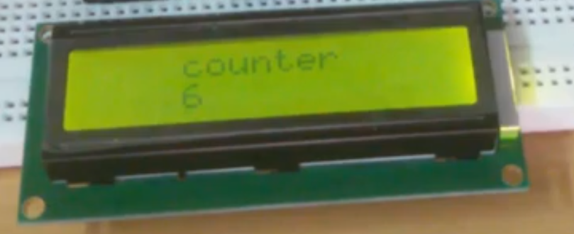

Screenshot 6.1: LCD Display

The unit of display where person count is displayed with a LCD screen which shows current count and display it easily.

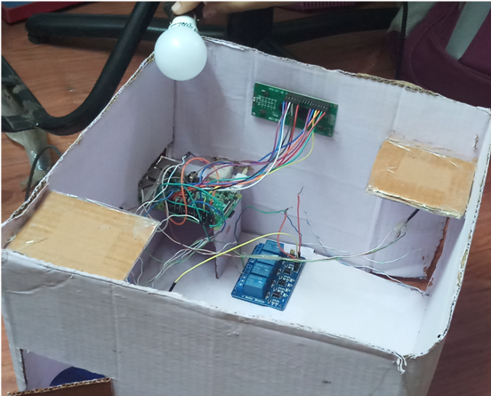

Screenshot 6.2: Final Model

A stage of automatically turning light ON and OFF in the classroom by detecting the human movement using infrared (PIR) sensors.

b) Testing

1) Unit test cases generation and its testing reports

Table 6.1.Unit test cases generation and its testing reports

|  |  |  |  |  |  |
| --- | --- | --- | --- | --- | --- |
| Test case No | Test case | Input | Expected output | Actual output | Status |
| **01** | First PIR sensor | Person Entered | Person Detection and sends signal to Raspberry Pi | Person Detection and sends signal to Raspberry Pi | Pass |
| **02** | Second PIR sensor | Person Exited | Person Detection and sends signal to Raspberry Pi | Person Detection and sends signal to Raspberry Pi | Pass |
| **03** | LCD Display | Signal from Raspberry Pi | Display count | Display count | Pass |
| **04** | Relay | Signal from Raspberry Pi | Respectively relay will be turned On/Off and sends signal to bulb | Respectively relay will be turned On/Off and sends signal to bulb | Pass |
| **05** | Bulb | Signal from Relay | ON/OF Light. | ON/OFF  Light. | Pass |

2) Integration test cases generation and its testing reports

Table 6.2 Integration test cases generation and its testing reports.

|  |  |  |  |  |  |
| --- | --- | --- | --- | --- | --- |
| Test case No | Test case | Input | Expected output | Actual output | Status |
| **01** | First PIR sensor | Person Entered | Person Detection and sends signal to Raspberry Pi | Person Detection and sends signal to Raspberry Pi | Pass |
| **02** | Second PIR sensor | Person Exited | Person Detection and sends signal to Raspberry Pi | Person Detection and sends signal to Raspberry Pi | Pass |
| **03** | LCD Display | Signal from Raspberry Pi | Display count | Display count | Pass |
| **04** | Relay | Signal from Raspberry Pi | Respectively relay will be turned On/Off and sends signal to bulb | Respectively relay will be turned On/Off and sends signal to bulb | Pass |
| **05** | Bulb | Signal from Relay | ON/OF Light. | ON/OFF  Light. | Pass |

3) System test cases generation and its testing reports

Table 6.3 System test case generation and its testing report

|  |  |  |  |  |  |
| --- | --- | --- | --- | --- | --- |
| Test case No | Test case | Input | Expected output | Actual output | Status |
| **01** | System  Working | Signal from PIR sensor | Light On | Light On | Pass |
| **02** | System  Working | Signal from PIR sensor | Light OFF | Light OFF | Pass |

**7. Performance Analysis**

1. This PIR (Passive Infrared) sensor detects the person on the basis of body temperature within the range of 3 meters.
2. It sends signal to raspberry pi board in the form of 0 or 1.
3. When person detected then it sends 1 else it sends 0.
4. Raspberry pi accept it and send signal to relay board and it also sends to LCD display. i.e count will be displayed on LCD display.
5. Then light (bulb) will be ON or OFF and display count on the LCD display.

**8. Applications**

1. The system can be used in classroom/organization to turn light ON and OFF automatically.
2. Helpful to save energy.(e.g. home appliances, office etc.)

**9. Installation guide and user manual**

Following are the steps to install Raspbian:

Pre-requisite:

1.Install Raspbian Operating System.

Installation Steps:

1. Search raspbian OS on raspbian official site.
2. Two ways to install
   1. install with NODBS
   2. install with Flash
3. Download desktop version 1.64GB
4. Download 7Zip file executer.
5. Download etcher.io
6. Write click on zip file and extract this file
7. Install SD Card formatting

Select memory card🡪click yes

1. Click on Finish.

**10. Ethics**

As an Information Technology student, We believe it is unethical to,

1. Surf the internet for personal and non-class related purposes during classes
2. Make a copy of software for personal or commercial use.
3. Make a copy of software for a friend
4. Loan CDs of software to friends
5. Download pirated software from the internet
6. Distribute pirated software from the internet
7. Buy software with a single user license and then install it on multiple computers
8. Share a pirated copy of software
9. Install a pirated copy of software

**11. References**

[1] H.N.S.Anusha, T.Rajath, P.Soundarya ,” Automatic Lighting And Control System For Classroom”, 978-1-5090-5515-9/16/$31.00 ©2016 IEEE.

[2] Himanshu Singh, Vishal Pallagani, Vedant Khandelwaland Venkanna, “IoT based Smart Home Automation System using Sensor Node”, 978-1-5386-3039-6/18/$31.00©2018 IEEE.

[3] Rachel Dunning, Jasbir Harnal, Bradley Barrett, Sinan Yucesan, Benjamin

Browning ,Thomas Harrison, and Gregory C. Lewin, “Automated

Lighting System for Park Pathways”, 978-1-5386-1848-6/17/$31.00 ©2017 IEEE.

[4] Manjeet Singh, Shimi S.L. “Implementation of Room Automation With

Cloud Based Monitoring System”, 978-1-5386-0807-4/18/$31.00 ©2018 IEEE.